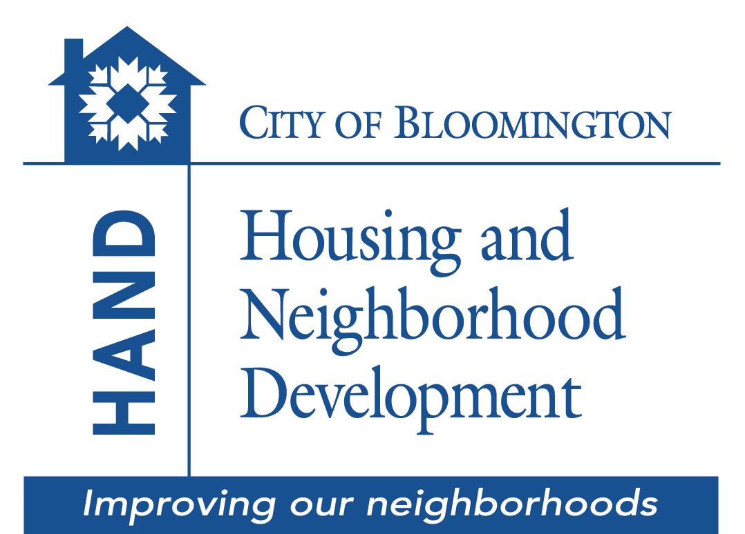

Owner-Occupied Rehabilitation
A loan program that offers affordable financing to qualified homeowners within the
City of Bloomington jurisdiction to make property improvements.

Application

Submit completed application and all requested information to:

City of Bloomington Housing and Neighborhood Development (HAND)

Showers City Hall, Suite 130
401 N. Morton Street, P.O. Box 100
Bloomington, IN 47402

(812) 349-3401
HAND@bloomington.in.gov

Funds are available on a first-come, first-serve basis.
Funding is contingent upon the availability of funds.

Dear Homeowner(s):

Through the Owner-Occupied Rehabilitation (OOR) loan program the City of Bloomington Department of Housing and Neighborhood Development (HAND) is providing property rehabilitation funding of up to $38,500 with the goal of restoring the health and safety your home. The loan covers all costs associated with the rehabilitation project (labor, supplies, and materials). HAND manages the project from start to finish, which includes developing a scope of work, placing the work out to bid, and establishing a contract with a contractor to complete the work. HAND inspects the work for approval prior to making payments to the contractor.

All awards of funding for a proposed project are contingent upon a complete Environmental Review. No action can be taken until the Environmental Review has been completed and funding agreements have been signed and executed.

TO BE ELIGIBLE, YOU MUST:

- Be an owner and primary occupant of a property within the Bloomington corporate city limits
- Have a valid Homeowner’s Insurance Policy in place.
- Be current on your property taxes.
- Meet underwriting guidelines for the OOR loan program.
- Have a maximum total family income (including all adult members of the household and all sources of income) of no more than*:

Household Size | 1 | 2 | 3 | 4 | 5 | 6
Maximum Annual Household Gross Income | $47,800 | $54,600 | $61,450 | $68,250 | $73,750 | $79,200

*2022 Income Guidelines. Income guidelines are subject to change.

Applications are prioritized for funding purposes on a first-come, first-served basis. A completed application and all supporting documentation requested is needed to be considered for the program. The following page is a checklist list of what information you will be required to provide to submit a completed application.

Checklist

APPLICATION
_____ Four page application with signature(s) and date(s)

_____ Attached Authority to Verify Credit information form with signature(s) and date(s)

_____ Part I & II of attached Verification Forms (deposits, employment, mortgage)

PROOF OF HOME OWNERSHIP
_____ Deed to property

_____ Most recent mortgage statement

PROOF OF RESIDENCY
_____ Copy of a current utility bill (i.e. water, gas, telephone, or electricity bill)

PROOF OF HOMEOWNERS INSURANCE
_____ Copy of the homeowners insurance policy

PROOF OF INCOME ELIGIBILITY FOR ALL HOUSEHOLD MEMBERS 18+
_____ Last two months of paycheck stubs

_____ If self-employed, copy of year to date profit & loss statement

_____ Benefit or entitlement letter for Social Security, annuities, insurance policy benefits, retirement funds, pensions, unemployment, disability or death benefits, worker’s compensation, severance pay, alimony, child support, or Armed Forces income. (direct deposit bank statements cannot be accepted)

_____ Prior year’s Federal and State tax forms with all attachments or written statement that applicant does not file taxes

_____ Most recent monthly bank statement(s)

_____ If a household member does not have any source of income, provide a signed written statement of the fact.

Submit Application to:
City of Bloomington HAND
Showers City Hall, Suite 130 Application Date:
401 N. Morton Street, P.O. Box 100
Bloomington, IN 47402
Owner-Occupied Rehabilitation Application

Personal Information
Full Name: _____________________________________________________________

Property Address: _____________________________________________________________

_____________________________________________________________

Primary Phone: ___________________________ Alternate: _________________________

Email: _____________________________________________________________

SSN: __________________________ DOB: _____________________________

Are you a “female head of household”, which is defined as an adult female with dependents and no male significant other?  Yes  No

Do you consider yourself to be Hispanic (check one):  Yes  No

Please indicate how you identify yourself by checking only one of the following:

❐ White  Black/African American
❐ Asian  American Indiana/Alaskan Native
❐ Native Hawaiian/Other Pacific Islander  Asian & White
❐ American Indiana/Alaskan Native & White  Black/African American and White
❐ American Indiana/Alaskan Native  Other/Multi-racial
& Black/African American
Household Composition
Total Number of Persons in household: ________ . Please list all members below:
FULL NAME | RELATIONSHIP | AGE | SOCIAL SECURITY
Employment and Financial Information

Applicant:
Are you employed?   Yes  No | Since when?  __________ | Employers’s Name and Address:

Co-applicant:
Are you employed?   Yes  No | Since when?  __________ | Employers’s Name and Address:

Please list all sources of GROSS monthly income for all adult household members:

Source | Applicant | Co-Applicant | Household Member 18 or Older | Total
Employment
Self Employment
Social Security (SSI)
Disability (SSI)
Pensions/Retirement
Alimony/Child Support
Investment
Net Rental Income
Unemployment Benefits
Workers Compensations
Other (list source):
Total
Please list your household financial assets:

Type | Cash Value | Annual Income From Assets | Financial Institution Name
Checking Accounts
Savings Accounts
Stocks/IRA
U.S. Savings Bonds
Other Real Estate
Other (list source):

Please List outstanding debt obligations (auto loans, credit cards, charge accounts, personal loans, real estate loans (except for the home you live in), and child support payments).

Type | Creditor’s Name | Monthly Payment | Unpaid Balance
 |  |  | Total
If a “Yes” answer is given to any of the following questions please explain on a separate sheet:
1. Do you have any outstanding upaid judgements?  Yes  No Amount: $_________
2. In the past 7 years, have you declared bankruptcy?  Yes  No
3. Are you a party to any active lawsuits?  Yes  No

Please list your Monthly Housing Expenses:

Item | Monthly Payment
Mortgage Payment
Homeowner’s Insurance
Real Estate Taxes
Water/Sewer
Electric
Gas
Home Maintenance
Other:
 | TOTAL:

Property Information

Are you the Owner-Occupant of the property to be rehabilitated?  Yes  No

How many years have you occupied the home?  Less than 1 year  1 to 5 years  Over 5 years

What year was your home built? ______________ How many bedrooms? ______________

What year did you buy your home? ____________ Current estimated value? ______________

Original Mortgage Amount: __________________ Current Mortgage Balance: _____________

Lender Name and Address:_______________________________________________________

Have you utilized a HAND home repair/rehabilitation program before?  Yes  No
If yes, what year? _____________

Briefly describe the scope of rehabilitation work envisioned. Attach a separate sheet if more room is necessary.

_____________________________________________________________________________
____________________________________________________________________________________________________________________________________________________________________________________________________________________________________________________________________________________________________________________

The information provided below is true and complete to the best of my/our knowledge and belief. I/we consent to the disclosure of such information for purposes of income and verification related to my/our application for financial assistance. I/we understand that any willful misstatement of material fact will be grounds for disqualification.

APPLICANT: CO-APPLICANT:

Print Name: _________________________ Print Name: _________________________

Signature: _________________________ Signature: _________________________

Date: _________________________ Date: _________________________

AUTHORITY TO VERIFY CREDIT INFORMATION

This is your authority to verify my bank accounts, employment, outstanding debts, including any present or previous mortgages, to order a consumer credit report, and to make any other inquiries pertaining to my qualification for a grant from you. You may make copies of this letter for distribution to any party with which I have a financial or credit relationship and that party may treat such copy as an original.

PRIVACY ACT NOTICE: This information is to be used by the agency collecting it or its assignees in determining whether you qualify as a prospective grantee under its program. It will not be disclosed outside the agency except as required and permitted by law. You do not have to provide this information, but if you do not, your application for approval as a prospective grantee may be delayed or rejected.

Applicant 1:

Print Name:______________________________

________________________________________ __________________________
Signature Date Social Security Number

Applicant 2:

Print Name:______________________________

________________________________________ __________________________
Signature Date Social Security Number

Verification of Employment

The applicant identified below has applied for loan through the Housing and Neighborhood Development Department, City of Bloomington. The individual has authorized your release of the required information. The information you provide will be used only for the purposes of determining eligibility for the loan. We are required to complete our verification process in a short time period and would appreciate your prompt response. If you have any questions, please feel free to contact Dan Niederman, Program Manager at 812-349-3512. Thank you.

Part I. Applicant Information (To be completed by applicant)

Name of Applicant _______________________________________
Address of Applicant _______________________________________
_______________________________________
Part II. Employer Information (To be completed by applicant)

Name of Employer _______________________________________
Address of Employer _______________________________________
_______________________________________
Part III. Employment Information (To be completed by employer)

1. Date of Employment: _______________ Position/Occupation: __________________
- Date of Termination (if applicable): ________________
- Current Rate of Regular Pay $__________ per __________ (hour, week, month, year, etc.)
- Current Rate of Overtime Pay $__________ per __________ (hour, week, month, year, etc.)
- Do you anticipate any change in the employee rate of pay in the near future?
□ Yes □ No. If yes: Revised Rate __________ Effective Date __________
- Number of hours/weeks employee normally works ____________________
- Do you anticipate any change in the number of hours the employee works: □ Yes □ No
If yes, explain under #14 below.
- Anticipated average amount of overtime/week ___________
- Gross annual earnings you anticipate for this employee for the next twelve months.
(Gross amount including all tips, bonuses, overtime, commissions) $___________________
10. Does this employee receive vacation with pay? □ Yes □ No
11. Does this employee receive sick leave pay? □ Yes □ No
- If the employee’s work is seasonal or sporadic, indicate lay-off periods: _______________________
13. Does this employee receive an earned income tax credit? □ Yes □ No
- Additional Comments:_______________________________________________________________
_________________________________________________________________________________
Completed by: Name: ________________________________________
Title: ________________________________________
Signature: ________________________________________
Date: ________________________________________
Tele. No.: ________________________________________

Warning: Section 1001 of Title 18 of the U.S. Code makes it a criminal offense to make willful false statements or misrepresentations to any Department or Agency of the United States as to any matter within its jurisdiction.

Verification of Employment

The applicant identified below has applied for loan through the Housing and Neighborhood Development Department, City of Bloomington. The individual has authorized your release of the required information. The information you provide will be used only for the purposes of determining eligibility for the loan. We are required to complete our verification process in a short time period and would appreciate your prompt response. If you have any questions, please feel free to contact Dan Niederman, Program Manager at 812-349-3512. Thank you.

Part I. Applicant Information (To be completed by applicant)

Name of Applicant _______________________________________
Address of Applicant _______________________________________
_______________________________________
Part II. Employer Information (To be completed by applicant)

Name of Employer _______________________________________
Address of Employer _______________________________________
_______________________________________
Part III. Employment Information (To be completed by employer)

1. Date of Employment: _______________ Position/Occupation: __________________
- Date of Termination (if applicable): ________________
- Current Rate of Regular Pay $__________ per __________ (hour, week, month, year, etc.)
- Current Rate of Overtime Pay $__________ per __________ (hour, week, month, year, etc.)
- Do you anticipate any change in the employee rate of pay in the near future?
□ Yes □ No. If yes: Revised Rate __________ Effective Date __________
- Number of hours/weeks employee normally works ____________________
- Do you anticipate any change in the number of hours the employee works: □ Yes □ No
If yes, explain under #14 below.
- Anticipated average amount of overtime/week ___________
- Gross annual earnings you anticipate for this employee for the next twelve months.
(Gross amount including all tips, bonuses, overtime, commissions) $___________________
10. Does this employee receive vacation with pay? □ Yes □ No
11. Does this employee receive sick leave pay? □ Yes □ No
- If the employee’s work is seasonal or sporadic, indicate lay-off periods: _______________________
13. Does this employee receive an earned income tax credit? □ Yes □ No
- Additional Comments:_______________________________________________________________
_________________________________________________________________________________
Completed by: Name: ________________________________________
Title: ________________________________________
Signature: ________________________________________
Date: ________________________________________
Tele. No.: ________________________________________

Warning: Section 1001 of Title 18 of the U.S. Code makes it a criminal offense to make willful false statements or misrepresentations to any Department or Agency of the United States as to any matter within its jurisdiction.

Verification of Deposits

The applicant identified below has applied for a loan with the Housing and Neighborhood Development Department, City of Bloomington. The information you provide will be used only for the purpose of determining the family’s eligibility for the program. We are required to complete our verification process in a short time period and would appreciate your prompt response. A self-addressed envelope has been included for your convenience. If you have any questions, please feel free to contact Dan Niederman, Program Manager, at 812-349-3512. Thank you.

Part I. Applicant Information (To be completed by applicant)

Name of Applicant: _______________________________________ SSN:___________________________
Address of Applicant: _______________________________________
_______________________________________

Part II. Bank Information (To be completed by applicant)

Name of Bank: _______________________________________
Address of Bank: _______________________________________
_______________________________________

Part III. Deposit Information (To be completed by institution)

Checking Account
Account Number(s) | Average 6-Month Balance ($)
 | $
 | $
Is this an interest bearing account? □ Yes □ No
If yes, annual interest rate ________%
Savings Account
Account Number(s) | Present Account Balance(s) | Annual Interest Rate | Withdrawal Penalty
 | $ | %
 | $ | %

Certificate of Deposit
Account Number(s) | Present Account Balance(s) | Annual Interest Rate | Withdrawal Penalty
 | $ | %
 | $ | %

Trust
Value of Trust Fund Administered: $ ______________________
Anticipated Amount of Income to be Earned by Trust over next 12 Months: $ ______________________

Completed by: Name: ________________________________________
Title: ________________________________________
Signature: ________________________________________
Date: ________________________________________
Tele. No.: ________________________________________

Warning: Section 1001 of Title 18 of the U.S. Code makes it a criminal offense to make willful false statements or misrepresentations to any Department or Agency of the United States as to any matter within its jurisdiction.

Verification of Deposits

The applicant identified below has applied for a loan with the Housing and Neighborhood Development Department, City of Bloomington. The information you provide will be used only for the purpose of determining the family’s eligibility for the program. We are required to complete our verification process in a short time period and would appreciate your prompt response. A self-addressed envelope has been included for your convenience. If you have any questions, please feel free to contact Dan Niederman, Program Manager, at 812-349-3512. Thank you.

Part I. Applicant Information (To be completed by applicant)

Name of Applicant: _______________________________________ SSN:___________________________
Address of Applicant: _______________________________________
_______________________________________

Part II. Bank Information (To be completed by applicant)

Name of Bank: _______________________________________
Address of Bank: _______________________________________
_______________________________________

Part III. Deposit Information (To be completed by institution)

Checking Account
Account Number(s) | Average 6-Month Balance ($)
 | $
 | $
Is this an interest bearing account? □ Yes □ No
If yes, annual interest rate ________%
Savings Account
Account Number(s) | Present Account Balance(s) | Annual Interest Rate | Withdrawal Penalty
 | $ | %
 | $ | %

Certificate of Deposit
Account Number(s) | Present Account Balance(s) | Annual Interest Rate | Withdrawal Penalty
 | $ | %
 | $ | %

Trust
Value of Trust Fund Administered: $ ______________________
Anticipated Amount of Income to be Earned by Trust over next 12 Months: $ ______________________

Completed by: Name: ________________________________________
Title: ________________________________________
Signature: ________________________________________
Date: ________________________________________
Tele. No.: ________________________________________

Warning: Section 1001 of Title 18 of the U.S. Code makes it a criminal offense to make willful false statements or misrepresentations to any Department or Agency of the United States as to any matter within its jurisdiction.

Verification of Mortgage or Loan

The applicant identified below has applied for an Owner-Occupied Rehabilitation Loan. The applicant has authorized Housing and Neighborhood Development, City of Bloomington, to obtain verification of the status of this mortgage/loan on the property from you. This information will be kept strictly confidential and is for use by this Department and the US Department of Housing and Urban Development. Please furnish the information requested below and return it to HAND in the enclosed self-addressed, stamped envelope. If you have any questions, please call Dan Niederman at 812-349-3512. Thank you for your cooperation.

Part I. Applicant Information (To be completed by applicant)

Name of Applicant: ___________________________________________
Address of Applicant: ___________________________________________
___________________________________________
Mortgage/Loan Acct. #: ___________________________________________

Part II. Lender Information (To be completed by applicant)

Name of Lender: ___________________________________________
Address of Lender: ___________________________________________
___________________________________________

Part III. Mortgage/Loan Information (To be completed by lender)

Date of Mortgage/Loan: _____________ Original Principal Amount: ___________________
Date of Maturity: __________________ Current Principal Amount: ____________________

Monthly Payment: Principal and Interest: ____________________
Mortgage Insurance: ____________________
Real Estate Tax Escrow: ____________________
Hazard Insurance Escrow: ____________________
Other ( _____________): ____________________
Total Monthly Payment: ____________________

Are the payments current? ________. If no, amount in arrears: $__________ and period of arrears: _________.

Prepayment penalty: $ _______________

Completed by: Name: ________________________________________
Title: ________________________________________
Signature: ________________________________________
Date: ________________________________________
Tele. No.: ________________________________________

Warning: Section 1001 of Title 18 of the U.S. Code makes it a criminal offense to make willful false statements or misrepresentations to any Department or Agency of the United States as to any matter within its jurisdiction.

