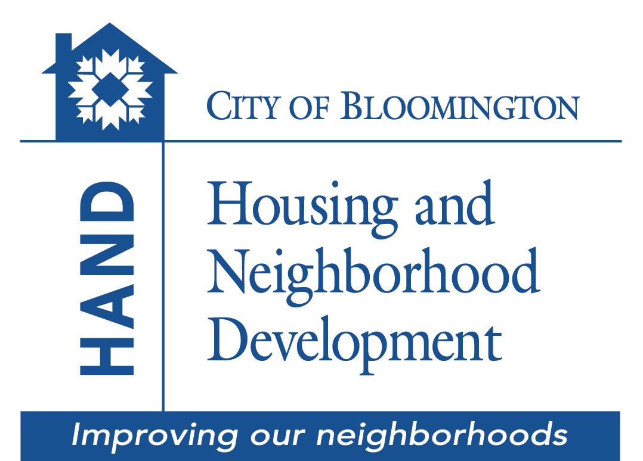

Home Modification for
Accessible Living Grant
A grant for qualified residents within the City of Bloomington jurisdiction
to improve the needed accessibility of a home.

Application

Submit completed application and all requested information to:

City of Bloomington Housing and Neighborhood Development (HAND)

Showers City Hall, Suite 130
401 N. Morton Street, P.O. Box 100
Bloomington, IN 47402

Phone (812) 349-3401
hand@bloomington.in.gov

Grant funds are available on a first-come, first-serve basis.
Grant is contingent upon the availability of funds.

Dear Applicant(s):

Through the Home Modification for Accessible Living (HMAL) program the City of Bloomington Department of Housing and Neighborhood Development (HAND) is providing a grant to make accessibility related improvements to residential properties for occupants with a disability. The grant covers all costs associated with the project (labor, supplies, and materials). HAND manages the project from start to finish, which includes developing a scope of work, placing the work out to bid, and establishing a contract with a contractor to complete the work. HAND inspects the work for approval prior to making payments to the contractor.

All awards of funding for a proposed project are contingent upon a complete Environmental Review. No action can be taken until the Environmental Review has been completed and funding agreements have been signed and executed.

TO BE ELIGIBLE, YOU MUST:

- Occupy the property (owned or rented) located within the Bloomington corporate city limits (mobile homes are eligible).
- Have a valid Homeowner’s Insurance Policy in place (not applicable to a rental unit)
- Be current on your property taxes ( not applicable to a rental unit)
- Have a maximum total family income (including all adult members of the household and all sources of income) of no more than*:

Household Size | 1 | 2 | 3 | 4 | 5 | 6
Maximum Annual Household Gross Income | $47,800 | $54,600 | $61,450 | $68,250 | $73,750 | $79,200

*2022 Income Guidelines. Income guidelines are subject to change.

Applications are prioritized for funding purposes on a first-come, first-served basis. A completed application and all supporting documentation requested is needed to be considered for the program. The following page is a checklist list of what information you will be required to provide to submit a completed application.

Checklist

APPLICATION
_____ Four page application with signature(s) and date(s)

_____ Attached Authority to Verify Credit information form with signature(s) and date(s)

PROOF OF HOME OWNERSHIP (not applicable for rental unit)
_____ Deed to property or title for mobile home

_____ If contract sale, provide copy of contract and a letter of consent from owner for project

PROOF OF RESIDENCY
_____ Copy of a current utility bill (i.e. water, gas, telephone, or electricity bill)

_____ For a mobile home, also provide proof your lot rent is current

PROOF OF HOMEOWNERS INSURANCE (not applicable for rental unit)
_____ Copy of the homeowners insurance policy

PROOF OF INCOME ELIGIBILITY FOR ALL HOUSEHOLD MEMBERS 18+
_____ Last two months of paycheck stubs

_____ If self-employed, copy of year to date profit & loss statement

_____ Benefit or entitlement letter for Social Security, annuities, insurance policy benefits, retirement funds, pensions, unemployment, disability or death benefits, worker’s compensation, severance pay, alimony, child support, or Armed Forces income. (direct deposit bank statements cannot be accepted)

_____ Most recent bank statement(s)

_____ Prior year’s Federal and State tax forms with all attachments or written statement that applicant does not file taxes

_____ If a household member does not have any source of income, provide a signed written statement of the fact.

_____ APPLICANT MUST PROVIDE A PERMISSION FORM SIGNED BY PROPERTY OWNER OR AN AUTHORIZED AGENT GRANTING PERMISSION FOR THE PROPOSED MOFICATIONS.

Submit Application to:
City of Bloomington HAND
Showers City Hall, Suite 130 Application Date:
401 N. Morton Street, P.O. Box 100
Bloomington, IN 47402
Home Modification for Accessible Living Application

Personal Information
Full Name: _____________________________________________________________

Property Address: _____________________________________________________________

_____________________________________________________________

Primary Phone: ___________________________ Alternate: _________________________

Email: _____________________________________________________________

SSN: __________________________ DOB: _____________________________

Are you a “female head of household”, which is defined as an adult female with dependents and no male significant other?  Yes  No

Do you consider yourself to be Hispanic (check one):  Yes  No

Please indicate how you identify yourself by checking only one of the following:

❐ White  Black/African American
❐ Asian  American Indiana/Alaskan Native
❐ Native Hawaiian/Other Pacific Islander  Asian & White
❐ American Indiana/Alaskan Native & White  Black/African American and White
❐ American Indiana/Alaskan Native  Other/Multi-racial
& Black/African American
Household Composition
Total Number of Persons in household: ________ . Please list all members below:
FULL NAME | RELATIONSHIP | AGE | SOCIAL SECURITY
Employment and Financial Information

Applicant:
Are you employed?   Yes  No | Since when?  __________ | Employers’s Name and Address:

Co-applicant:
Are you employed?   Yes  No | Since when?  __________ | Employers’s Name and Address:

Please list all sources of GROSS monthly income for all adult household members:

Source | Applicant | Co-Applicant | Household Member 18 or Older | Total
Employment
Self Employment
Social Security (SSI)
Disability (SSI)
Pensions/Retirement
Alimony/Child Support
Investment
Net Rental Income
Unemployment Benefits
Workers Compensations
Other (list source):
Total
Please list your household financial assets:

Type | Cash Value | Annual Income From Assets | Financial Institution Name
Checking Accounts
Savings Accounts
Stocks/IRA
U.S. Savings Bonds
Other Real Estate
Other (list source):

Please List outstanding debt obligations (auto loans, credit cards, charge accounts, personal loans, real estate loans (except for the home you live in), and child support payments).

Type | Creditor’s Name | Monthly Payment | Unpaid Balance
 |  |  | Total

Please list your Monthly Housing Expenses:

Item | Monthly Payment
Mortgage/Rent Payment
Homeowner’s Insurance
Real Estate Taxes
Water/Sewer
Electric
Gas
Home Maintenance
Other:
 | TOTAL:

Property Information

Do you occupy the property to receive assistance?  Yes  No

Do you own or rent the property to receive assistance?  Own  Rent

How many years have you occupied the property?  Less than 1 year  1 to 5 years  Over 5 years

If you own the property:

What year was your home built? ______________ How many bedrooms? ______________

What year did you buy your home? ____________

Original Mortgage Amount: ___________________________ Unpaid Balance_____________

Lender Name and Address:_______________________________________________________

Have you utilized a HAND home repair/rehabilitation program before?  Yes  No
If yes, what year? _____________

Briefly describe the modifications needed. Attach a separate sheet if more room is necessary.

_____________________________________________________________________________
_______________________________________________________________________________________________________________________________________________________________________________________________________________________________________

The information provided below is true and complete to the best of my/our knowledge and belief. I/we consent to the disclosure of such information for purposes of income and verification related to my/our application for financial assistance. I/we understand that any willful misstatement of material fact will be grounds for disqualification.

APPLICANT: CO-APPLICANT:

Print Name: _________________________ Print Name: _________________________

Signature: _________________________ Signature: _________________________

Date: _________________________ Date: _________________________

AUTHORITY TO VERIFY CREDIT INFORMATION

This is your authority to verify my bank accounts, employment, outstanding debts, including any present or previous mortgages, to order a consumer credit report, and to make any other inquiries pertaining to my qualification for a grant from you. You may make copies of this letter for distribution to any party with which I have a financial or credit relationship and that party may treat such copy as an original.

PRIVACY ACT NOTICE: This information is to be used by the agency collecting it or its assignees in determining whether you qualify as a prospective grantee under its program. It will not be disclosed outside the agency except as required and permitted by law. You do not have to provide this information, but if you do not, your application for approval as a prospective grantee may be delayed or rejected.

Applicant 1:

Print Name:______________________________

________________________________________ __________________________
Signature Date Social Security Number

Applicant 2:

Print Name:______________________________

________________________________________ __________________________
Signature Date Social Security Number

